Describing Leadership of Ordinary Individuals
George L. Siemon and John P. Mackey

Module 6 Assignment 1

By
Randy K. Pruitt

For – B6007
Dr. Gulbro
Date – 07 August 2010

In this article I shall discuss two people who began their leadership roles as ordinary people and then go on to assist in facilitating the growth of their business into very successful enterprises. The first person I shall discuss in each section is George L. Siemon who in 1988 started out as an organic farmer in Wisconsin he joined half a dozen organic farmers into the Cooperative Regions of Organic Producer Pools (CROPP) which formed the nucleus of Organic Valley which has become North Americas largest cooperative of organic farmers where George serves as the CEO for the Organic Valley Cooperative. The second person I shall discuss in each section is John P. Mackey who along with 19 other people in 1980 from meager beginnings opened up the original Whole Foods Market in Austin Texas where John has served as CEO of Whole Foods Market to this day.
The image to the right is that of George L. Siemon a founder and the CEO of Organic Valley Cooperative founded in 1988
The image to the left is that of John P. Mackey co-founder and the CEO of Whole Foods Market founded in 1980
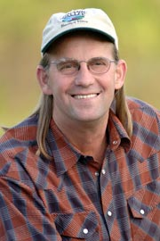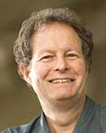

Above-just two ordinary folk that seized an
opportunity that came their way

Described the characteristics that allowed or motivated
the ordinary individuals to take up the
leadership opportunities

First – George L. Seimon has since 1977 owned and operated a family organic farm and envisioned himself a champion of systems that supports family farms that gives consumers high quality organic food that is without antibiotics or synthetic hormones and pesticides and George defends the ethical treatment of animals along with positive environmental benefits. And an overall vision that George supports at the Organic Valley Family of Farms as quoted off the their website is “as the co-op continues to grow, they prove that it is not necessary for a business to sacrifice people for profits: today, the cooperatives farmer-owners represent approximately 9 percent of the entire nation's certified organic farming community.” These are some of the prime motivators of George’s lending to a continued posture of leadership in the Organic Valley Family Farm Cooperative. According to Curtis & Manning (2009) pertaining to George L. Siemon, I would say George’s most predominant leadership style is that of stewardship building partnerships with equal responsibility across the cooperative.
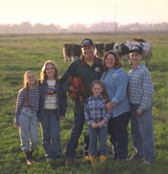
To the left a typical family farming unit, members of the Cooperative Regions of Organic Producer Pools (CROPP) the largest organic farming cooperative in North America with more than 1652 farmer-owners in 33 states and four Canadian provinces. George L. Seimon helped found CROPP which now falls under the brand label of Organic Valley Family of Farms.
Second – John P. Mackey co-founder of the Whole Food Market in 1980 and served as CEO ever since. John holds the core values true for the Whole Food Market chain. The following taken from wholefoodsmarket.com are the underpinning values that do not change over time and preserve what has always been special about the company:
- Selling the Highest Quality Natural and Organic Products Available
- Satisfying and Delighting Our Customers
- Supporting Team Member Happiness and Excellence
- Creating Wealth through Profits & Growth
- Caring about our Communities & Our Environment
- Creating ongoing win-win partnerships with our suppliers
- Promoting the health of our stakeholders through healthy eating education
Stating the Whole Foods Market customer service experience “we go to extraordinary lengths to satisfy and delight our customers. We want to meet or exceed their expectations on every shopping trip. We know that by doing so we turn customers into advocates for our business. Advocates do more than shop with us; they talk about Whole Foods to their friends and others. We want to serve our customers competently, efficiently, knowledgeably and with flair.” According to Curtis & Manning (2009) pertaining to John P. Mackey, I would say John, though certainly at the beginning there was the building of partnerships I see him most predominant in the style of change agent identifying the need for change across the organic and natural food business with notable obvious success.
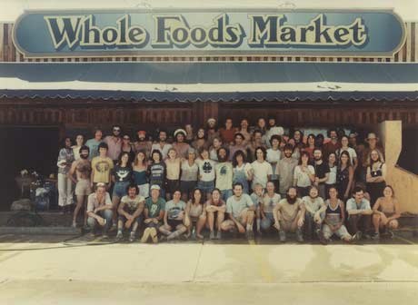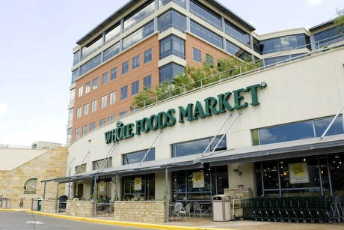
Above and to the left circa 1980s the original Austin Texas Whole Foods Market Store and above and to the right the same but today’s renovated Austin Texas Whole Foods Market Store. Note above and beyond the store’s red brick and glass offices. These offices now house the Whole Foods Market global operations center. Talk about a success story. Way to go John P. Mackey. Hay and John started out just an ordinary guy and the picture of the old store says it all.

All above images taken from organicvalley.coop and wholefoodsmarket.com

Identified the roadblocks faced by the leader
First – one of the obstacles or roadblocks facing George L. Siemon and the Organic Valley Cooperative in an interview with George L. Siemon by Rosy Ward of Bioneers George says there is a problem with the government planning process where the idea of sustainability doesn’t exist. George notes that support dollars are spent reactively in thought process rather than investing in preventative measures. And that right now subsidized farmers grow and sell corn for 1950s prices instead of subsidizing green manure or soil upkeep management at about the same cost. George interestingly states about the government and its policies “while we have a policy that's destroying the rural environment, there's another branch that's funding millions of dollars back into the rural environment to try to bring it back up to speed. So, you've got two opposing forces here.”
Second – one of the obstacles or roadblocks facing John P. Mackey initially was consolidation as noted above John was a co-founder of Whole Foods Market and at the beginning of his vision was the idea of creating a supermarket for the natural food business which at the time I do not believe he had any idea of the national chain of supermarkets that would arise from it, anyway John was a small business owner with a partner named Renee Lawson Hardy who together owned Safer Way Natural Foods and then there were two other people Craig Weller and Mark Skiles both co-partners in a natural food store called Clarksville Natural Grocery. Basically, it was a gamble for everyone to breakdown two small natural food stores, formulating a four-way partnership and combining resources for a full scale, at least in theory, a natural food supermarket rivaling other competitors wearing the term supermarket in scale. But by doing so there was strength in numbers and as it turned out Whole Foods Market became a quick success growing as is stated on wholefoodsmarket.com “We have grown by leaps and bounds since our first store opened.”

Determined the ethical dilemmas that the
leader needed to work with

First – one of the ethical dilemmas that George L. Siemon faces is that of educating people who work the land encouraging greater crop rotation and investment in the soil. George notes that in a society that is based on cheap food, costly land, and highly competitive market forces farmer’s plant vegetables on top of vegetables pushing their land to the limit without considering green manure or rotations. George says the results of this type of thinking links cheap food to the cheap care of the land. George also states in the interview Ward (2002) “if you look at the environmental movement, you'll rarely see agriculture mentioned. That's amazing, because agriculture, or even ranching, is a major land use in the United States and a major place to influence the way we care for the land. So the environmental movement has to wake up and support organic agriculture in their agenda.”

Second – one of the ethical dilemmas that John P. Mackey has had to face was with Whole Foods Market in its attempted acquisition of Wild Oats in 2007 which raised suspicions by government regulators who filed a complaint to the Federal Trade Commission (FTC) questioning the motives of Whole Foods Market claiming that the merger would form a monopoly hurting consumers. Thus a restraining order was placed on the merger. To quote an article from awpagessociety.com “The FTC filed and approved a formal complaint against Whole Foods Market in June 2007. The complaint stated that Whole Foods’ acquisition of Wild Oats, as proposed, would violate Section 5 of the FTC Act and Section 7 of the Clayton Act, as amended. According to the complaint, the merger would violate these sections by eliminating substantial competition between two close competitors in a number of markets throughout the nation in the operation of premium natural and organic supermarkets.” John P. Mackey was cited sending an e-mail to Whole Food’s Board of Directors favoring the merger, the e-mail stated “elimination of a competitor — they compete with us for sites, customers and team members.”

In rebuttal to the FTC claims Whole Foods Market admitted to the language quoted by the FTC about the e-mail Mackey had sent to the Board of Directors. The awpagessociety.com article states:

Whole Foods provided three arguments for defense against the FTC’s complaint that the merger would lead to Whole Foods’ likeliness to hurt consumers by raising prices and reducing its quality and services unilaterally:
1. The complaint fails to state a claim upon which relief can be granted.
2. Granting the relief sought is contrary to the public interest.
3. Efficiencies and other pro-competitive benefits resulting from the merger outweigh any and all proffered anti competitive effects.

So, John P. Mackey who started out this ordinary kind of guy now lives in a world a lot more complex.

References
awpagessociety.com, (2007, June 19) Whole Foods/Wild Oats Merger: Sowing the seeds for market growth, Retrieved August 5, 2010, from
http://www.awpagesociety.com/images/uploads/WholeFoods_CaseStudy.pdf

Curtis, K., & Manning, G. (2009) The Art of Leadership (3rd ed). New York: McGraw-Hill.
http://digitalbookshelf.argosy.edu/#/books/0077441141/pages/15408165

Organic Valley Family Farms Co-operative, organicvalley.coop (n.d.) George L. Siemon co-founder and CEO, Retrieved August 3, 2010, from http://www.organicvalley.coop/newsroom/about-organic-valley/our-ceo

Ward, R (2002, August 8) Heal the people, the land will follow; and interview with Organic Valley CEO George Siemon, Bioneers, Retrieved August 3, 2010, from http://www.organicvalley.coop

Whole Foods Market, wholefoodsmarket.com (n.d.) John P. Mackey co-founder and CEO, Retrieved August 3, 2010, from http://www.wholefoodsmarket.com/company

