Course Project: Final Paper

Module 8 Assignment 1

By
Randy K. Pruitt

For – B6006
Dr. Cornett
Date – 21 April 2011

Introduction

Wal-Mart Stores, Inc a name synonymous with the term retailing itself had its beginnings in 1962 who’s founder Sam Walton opened the first store offering one simple motto “everyday low prices” as a founding precept still in use today were taken from the Wal-Mart Corporation (2009) Annual report now heralds 7873 stores around the world.
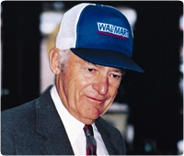
The image to the left taken from walmartstores.com is that of Sam Walton the founder of Wal-Mart Stores, Inc with the headquarters located at Walmart, 508 Southwest 8th Street Bentonville, AR 72716-0865

As Figure 1 below indicates there are enough stores across the U. S. and International markets to safely earn the phrase “everyone’s community market” which is precisely the reason I chose Wal-Mart as their stores are close to where people live and work everyday.
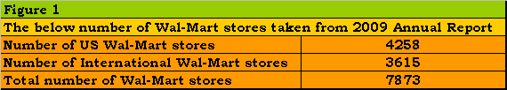

In this executive summary of the course project final paper, I shall review the following: The management profile of Wal-Mart Stores, Inc and its decision-making structures. Review Wal-Mart’s ethical principles that bind the company together as an effective organization. Review Wal-Mart’s and its electronic or e-business operations. Review Wal-Mart’s compliance with The Sarbanes-Oxley Act (SOX) of 2002. Review the workings of Wal-Mart’s sales and marketing channels and finally review the information technology that renders such a world-wide retailer to operate smoothly and efficiently as a competitive force. This shall be a compilation of work similar and in line with the narrative titled Course project: Draft submission. Where, I shall use charts, figures, graphs and descriptions from previous Modules with perhaps an addition or two as well as the more relevant terms they may apply across the subject matter involved.

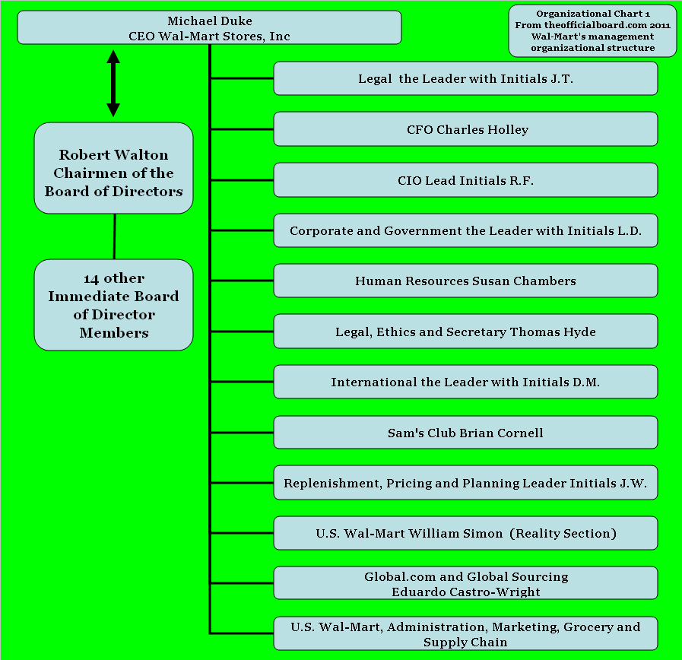
To the left as taken from theofficalboard.com is displayed Organizational Chart 1 Wal-Mart’s management organizational structure starting with Michael Duke Wal-Mart’s present CEO who is responsible for all Wal-Mart operations and answers to the son of founder Sam Walton, Robert Walton the present Chairmen of the Board of Directors.

As taken from McShane & Von Glinow (2010, p. 390) I shall define Wal-Mart’s management organizational structure through the use of the following key terms: One – The span of control or the number of people that report to any manager, taken from U.S. Wal-Mart’s 2009 sustainability report shows 66,170 managers to 1,388,429 employees.
Henri Fayol a management scholar a century ago recommended what he considered a narrow span of control of no more than 20 employees per supervisor and no more than 6 supervisors per manager. Figure 2 below is an approximation not based on hard data at least at this time but demonstrates how a narrow span of control might look as displayed as a bell curve. Note how across the base of Figure 2 is where the majority of the employees are the management spreads out narrowly across the base of the curve relatively complementing the 1 to 20.98 ratio that exists across store level operations. Here Wal-Mart is seems to be in line with Fayol’s advise.

Two – Centralized decision making where a small group of people make most of the decisions such as what is displayed as the top tier positions in the above Organizational Chart 1 with Wal-Mart. Three – Decentralized decision making where decisions are made across large groups such as with the lower tier employees spread across the base of Figure 2 where store workers given local customs for example would have the initiative to arrange items to better serve the local customer needs. Four – Mechanistic decision structure where procedures and rules are in place with tall hierarchies where tasks are rigidly defined such as such as what would be seen in the central and higher portion of Figure 2 as timetables to meet supply chain needs. Five – Organic decision structure a very decentralized decision-making system very elastic and fluid in function such as Wal-Mart associates out on the floor with customers. Six – Departmentalization where employees are grouped together in an organizational chart which establishes a chain of command, common ways of thinking, supervision or resource use from the global sustainability report “…we continually work to build efficient, productive and sustainable solutions into our business (Wal-Mart Corporation, 2009).”

As taken from the Wal-Mart statement of ethics at walmartstores.com Rob Walton the son of Wal-Mart’s founder states “When Sam Walton founded Wal-Mart, he instilled many principles and values within the company, three of which became our 3 Basic Beliefs to which we remain firmly committed, respect for the individual, service to the customer and striving for excellence. The global ethics office promotes Wal-Mart’s ethical culture to all stakeholders globally. Our Statement of Ethics gives our associates a reference guide to help them make ethical decisions.” Below Figure 3 displays common business ethical challenges and Wal-Mart’s response to them.
“Now more than ever my dad-built Wal-Mart for these times.” -Rob Walton

Taken from Boone & Kurtz (2011, p. 42) Pyramid 1 below portrays a hierarchy toward ethical structure. Below Pyramid 1 as a course workup I describe the terms used in the pyramid followed with an example from Wal-Mart’s statement of ethics.

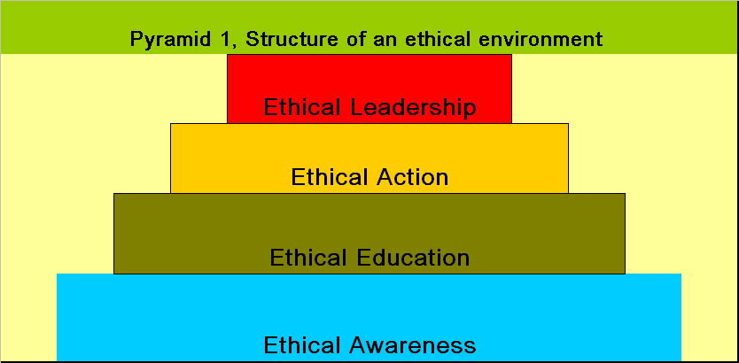
- Ethical leadership: Leaders best demonstrated by when you are wrong promptly admitting the error and then correcting it within the organization. From Wal-Mart’s additional responsibilities for management P. 7 “If an ethics issue arises with one of your associates, make sure other associates in your area are not making the same mistake.”  - Ethical action: The organizational structuring of codes, training, approaches and conduct in ethics that leads to actions of corrective decision making. From Wal-Mart’s using the statement of ethics P. 4 on how the statement of ethics is organized by the Wal-Mart organization across several categories giving guiding principles, an introduction to associate responsibilities, a section of concerns, speaking up and non-retaliation and an overview with commonly asked questions. This makes up the beginning of the Wal-Mart’s organizational codes for ethics. | - Ethical education: When a business provides the tools of education to employees assisting them with decision making on ethics. Wal-Mart compiled a 36 page highly detailed statement of ethics along with ethics training and local ethics committees to assist with ethics resolution as well as 24/7 access to the global ethics office.  - Ethical Awareness: begins with a climate conducive to ethical awareness where the organization provides guidance aimed at ethical behavior. Wal-Mart’s ethics education program is constructed to raise ethical awareness.  - Business ethics: The moral standards used of conduct, decisions and actions made in the work place. Wal-Mart’s CEO David Duke states P.3 on the statement of ethics “A strong commitment to ethics and integrity isn't just the right way to do business it’s how we earn the trust and respect that is critical to our success and our ability to help more people live.”

As a backdrop for this e-business review as noted across Figure 4 to the left are listed the primary business to business (B2B) and business to consumer (B2C) countries where Wal-Mart operates stores. Outside of direct store access by customers lays the e-commerce realm for Wal-Mart’s e-business customers. At walmartstores.com in a section called Shop at Wal-Mart e-commerce customers have the full access to all products out of any department available at stores such as:
- Electronics and office
- Home, furniture and outdoor
- Apparel, shoes and jewelry
- Baby and kids
- Toys and video games
- Sports and fitness
- Auto and home improvement
- Photo
- Crafts and party supplies
- Pharmacy, health and beauty
- Grocery and pets
- Top values and more

In Wal-Mart’s (2009) annual report cites $401 billion in total sales. As Reiss (2001, p. 320) states “For some (few) businesses areas for instance, e-business is nothing more than a “peanut”.” Figure 5 below displays this “peanut” relationship Wal-Mart’s e-commerce has dollar wise compared to the three main store branches of the company.

Below as a course workup is a list of key terms taken from Boone & Kurtz (2011, p., 214-217) where I shall explain the terms and then how those terms may best apply to Wal-Mart:

- Mixed market economies – This is where different types of economic systems such as planned (communism) and free market (capitalism) blend and operate simultaneously. Wal-Mart operates 243 stores in countries like China while doing business with hundreds of suppliers there as well.  - Electronic business (or e-business) – This is a reference of doing business over the internet. Wal-Mart maintains a website called Shop at Wal-Mart devoted to meeting customer needs by way of the Internet.  - Global reach – This term references how products can now thanks to the Internet be sold to customers around the world. Wal-Mart applies this global reach sales across those countries listed in Figure 4 above but also thanks to modern Intermodal shipping processes items can be bought, sold, tracked, shipped and delivered door to door anywhere in the world. | - Personalization – This refers to when orders are customized to fit the needs of the customers. Here one of Wal-Mart’s core beliefs and values is “Service to our customers through the quality of merchandise, best customer service and exceed customer expectations.” And this applies to customizing orders whenever possible to meet those customer expectations.  - Interactivity – This term applies to the negotiation of prices online between customers and suppliers to create products to the satisfaction of both parties. Another Wal-Mart core belief and value is “striving for excellence by bringing new ideas and goals to life, not being satisfied with the low prices as they are and always asking: Is this the best that I can do?” This idea underscores Wal-Mart’s search to bring innovative products to customers and streamlining supplier processes such as with the newer type of online DC’s a cost cutting measure meeting the satisfaction of both parties. | - Right-time and integrated marketing – This term applies to the coordination of communication and promotional activities to create a cohesive easy to understand message aimed at full customer satisfaction throughout ordering to delivery. Wal-Mart’s Shop at Wal-Mart website is easy to use and understand with the item categories running down the left-hand column of the website with all best priced or sale items in center view where the shopping cart, account information and so on is easily accessed on the top tool bar.  - Cost savings – This term applies to the savings a company has in costs due to a start up as an e-business. Well obviously, in 1962 Wal-Mart did not start up as an e-business. But over the years Wal-Mart has been an innovator as how business gets done from supplier to customer with the greatest advancement with their DC approach adding greatly to the efficiency of operations saving costs along the way. And now with Wal-Mart’s online DC’s the company slogan “everyday low prices” has a new venue across the Internet.

Wal-Mart over the years is not immune to the changes in global perspective, rising responsibilities and accountabilities levied across corporate structures. As a result of the ethical debacles with companies such as Enron and MCI-WorldCom the Sarbanes-Oxley Act (SOX) of 2002 was enacted. This was done to satisfy openness and transparency in financial reporting and accountability through the personal responsibility of officers that serve at publicly owned corporations. This has had a ripple effect across businesses in terms of compliance and the expenses involved especially with small businesses where legal fees have grown yearly. “SOX's most expensive provision, Section 404, requires companies to assess their own financial reporting controls, and then pay a third-party auditor for an independent assessment (Boone & Kurtz, 2011, p. 530).” Here Wal-Mart hired the third party independent public accounting firm of Ernest & Young, LLP. To meet the compliance of SOX on the management’s report to its shareholders Michael Duke Wal-Mart’s CEO and CFO Thomas Schoewe attests to being responsible for the annual report as well as sections titled Report on internal control over financial reporting, Evaluation of disclosure controls and procedures and the Report on ethics statement. (Wal-Mart Corporation, 2010, p. 54) Below taken from SOX Section 302 requires the following certifications which I will include Wal-Mart’s response to on publicly traded financial reports:
- The signing officers have reviewed the report – in Wal-Mart Corporation (2010, p. 54) in a section titled Management’s report to our shareholders the CEO Michael Duke and CFO Thomas Schoewe have signed having reviewed the 2010 annual report.  - The report does not contain any material untrue statements or material omission or be considered misleading – independent auditor, Earnest & Young LLP state “We conducted our in accordance with the standards of the Public Company Accounting Oversight Board (United States). Those standards require that we plan and perform the audit to obtain reasonable assurance about whether the financial statements are free of material misstatement (Wal-Mart Corporation, 2010, p. 52).”  - The financial statements and related information fairly present the financial condition and the results in all material respects - in the (Wal-Mart Corporation, 2010, p. 30-33) annual report it lists very openly the consolidated statements of income, consolidated balance sheets, consolidated statements of shareholders’ equity and a consolidated statements of cash flows where detailed lists of revenues, costs and expenses and operating income are seen as a few examples. | - The signing officers are responsible for internal controls and have evaluated these internal controls within the previous ninety days and have reported on their findings – on (Wal-Mart Corporation, 2010, p. 53) the Wal-Mart’s CEO and CFO certified the integrity of the report through their signatures.  - A list of all deficiencies in the internal controls and information on any fraud that involves employees who are involved with internal activities – (Wal-Mart Corporation, 2010, p. 46-53) starting with section 11 titled Legal proceedings there are discussions about class action cases, gender discrimination cases, hazardous materials investigations and an example of an un-audited quarterly data spread sheet. But no there was no mention about any possible errors in calculation or how such errors could occur.  - Any significant changes in internal controls or related factors that could have a negative impact on the internal controls – no I did not note internal control changes in the Wal-Mart Corporation (2010) annual report which would indicate a negative impact on such controls.

I found only one real break in compliance, I did not see a page on the Wal-Mart Corporation (2010) annual report where any of the calculations used could be in error and how those errors could be founded and corrected as a mechanism used for any needed control changes. Whether this leads to any misconstrued perceptions in sales or marketing data is unknown as it does leave an empty place where re-corrective formula should exist.
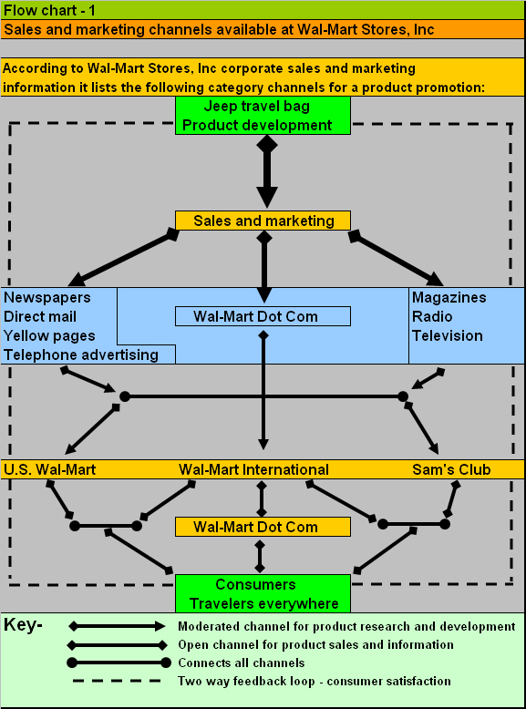

As taken from the Wal-Mart Stores, Inc corporate office, sales and marketing department information as portrayed to the left in Flow Chart 1 are the sales and marketing channels available for products across the Wal-Mart system. Here I use something common on the shelf at Wal-Mart stores and accessible at Wal-Mart International, Sam’s Club and Wal-Mart Dot Com the basic go everywhere Jeep Travel Bag available in several colors. Here the advertising pathways are shown in blue while the sales and marketing contact interface with customers is shown in orange. The area in green offers feedback between product development and the customers. The key shows the type of information or feedback noted by the different arrows used on Flow Chart 1.

Grean & Shaw (n.d., p. 4) notes that in 1988 Wal-Mart Stores, Inc was experiencing supply chain and customer relations problems with such companies as Proctor and Gamble (P&G) where the solution was the setting up of a centralized information system and the establishment of an electronic data interchange (EDI) system. As a result of EDI, the profitability between P&G and Wal-Mart went from $375 million in 1988 to over $4 billion dollars today. The EDI system was enabled to smooth over Wal-Mart’s external communication with suppliers and manufactures to trim down and more closely match consumer ordering cycle’s actual needs with products on a one-to-one relationship.
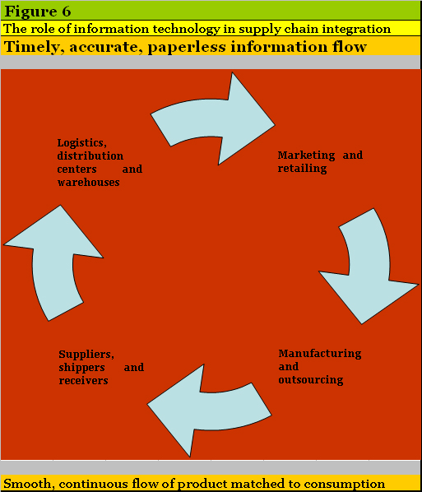
Figure 6 to the left illustrates how EDI systems cut across departments such as marketing and retailing, manufacturing and outsourcing, suppliers, shippers and receivers, logistics, distribution centers and warehouses. All designed to maintain an accurate and timely flow of information. The real gains in efficiency across Wal-Mart’s information technology (IT) system has resulted from the implementation of radio frequency identification (RFID) tags. RFID allows for high resolution synchronization across the supply chain of product data between shippers or receivers and distribution centers or stores and marketing or administration globally including improving e-commerce efficiency across the world.

Below and to the right as a course workup taken from Scribd.com (2008) is the general chronology and department connectivity advantages to Wal-Mart’s IT system which includes:  - Centralized communications developed throughout the 1990s  - A global $600 million telecommunications link set up for all Wal-Mart facilities  - First stage - Stores linked to central computer system  - Second stage - Central computer system linked to suppliers  The benefits:  - Direct reordering and coordination  - Lesser money in inventory  - Lower manufacturing costs  - Bar Code History &RFID  - Bar Code came into being in 70s  - Development of Universal Product Code (UPC) | Incoming shipments with RFID tags  The benefits:  - One stop information  - Control on physical movement  - Lesser time to find  - Non profit subsidiary of Uniform Code Council (UCC)  - UCC net  - Provides data registry service for supply chain management (SCM)  - Collaboration between suppliers and marketers  - Came into being to counter lack of data synchronization  - Suppliers need to be UCC net compliant  - Product details made available electronically  - Reduces product data-entry time


The image to the left is that of Linda Dillman in 2004 Wal-Mart’s CIO who took on the challenge of setting up the RFID tracking system across Wal-Mart and at that time considered by some the most powerful CIO in the world. In a statement issued by Dillman at that time I quote “Radio-frequency identification has a bigger potential to change retailing than anything Wal-Mart's ever done (Sullivan, 2004).”

“The nucleus of the IT infrastructure Dillman presides over is a single, centralized, 423-terabyte Teradata system that churns data from 1,387 discount stores, 1,615 Supercenters, 542 Sam's Clubs, and 75 Neighborhood Markets in the United States, plus 1,520 more stores worldwide (Sullivan, 2004).”
With the kind of centralized IT infrastructure Wal-Mart has corporate managers using enterprise resource planning (ERP) systems tied across the EDI synced with RFID tracking improve Wal-Mart’s efficiency gaining greater profitability. One of the improvements Might be with the addition of heuristics across the IT system. As (Merriam- webster.com, n.d.) defines heuristics as “…problem-solving techniques that utilize self-educating techniques (as the evaluation of feedback) to improve performance…” And this improved performance would lead toward even greater “every day low prices.”
Summary
In 1962 Sam Walton founder of Wal-Mart held to a dream of offering people “every day low prices” and now that dream has become realized across the world. This has occurred due to superb management practices in the span of control and decision making across the company, where Wal-Mart continually works to build efficient, productive and sustainable solutions into the company. Where Walton instilled three basic beliefs into the company’s fabric, respect for the individual, service to the customer and striving for excellence and these beliefs is the base for Wal-Mart’s global ethical principles. These principles cross over from the traditional store model to new enterprises such as Wal-Mart’s e-commerce that offers everyone on the Internet those “everyday low prices” to all products sold. Here Wal-Mart understands the ethical challenges changing and adapting to new business methods and operations following such legislation such as the Sarbanes-Oxley Act (SOX) of 2002 attempting to meet the higher standards now required by society. Here the sales and marketing departments use all of the communication mediums available to meet the product needs of a growing society assisted by one of the finest IT systems in the world to process a smooth and continuous flow of products matched to consumption.

Conclusion

Throughout the above discourse Wal-Mart is seen as a growing global retailer providing the world with goods and services attempting to further the dreams of its founder Sam Walton offering people everywhere those “every day low prices.”

References
Below the complete list of resources used for the company review for this course project on Wal-Mart Stores, Inc.

Boone, L.E., & Kurtz, D., L., (2011) Contemporary business (13th ed). John Wiley & Sons, Inc. Retrieved March 1, 2011, from
http://digitalbookshelf.argosy.edu/#/books/9780470879900/pages/15126307

Global Ethics Office, walmartstores.com, Retrieved March, 09, 2011, from
http://walmartstores.com/AboutUs/280.aspx

Grean, M. & Shaw, M., J., (n.d.) Supply-Chain integration through information sharing: channel partnership between Wal-Mart and Proctor & Gamble, Retrieved April 9, 2011, from http://citebm.business.illinois.edu/it_cases/Graen-Shaw-PG.pdf
McShane, S.L., & Von Glinow, M. A. (2010) Organizational behavior: Emerging knowledge and practice for the real world (5th ed.). New York: McGraw-Hill

Merriam-webster.com (n.d.) Definition of heuristic, Retrieved April 9, 2011, from
http://www.merriam-webster.com/dictionary/heuristic

Nielsen J., (2005) Ten usability heuristics, Retrieved April 9, 2011, from
http://www.useit.com/papers/heuristic/heuristic_list.html

Operational structure Wal-Mart, Inc. Retrieved July, 02, 2011, from
http://www.walmartstores.com/aboutus/

Organizational Chart Wal-Mart stores at theofficalboard.com, Retrieved March, 02, 2011, from
http://www.theofficialboard.com/company/search?q=Wal-Mart+Stores

Reiss, M., S., (2001) E-business: basics and challenges, Wichmann verlag, Heidelberg, Retrieved March 16, 2011, from http://www.ifp.uni-stuttgart.de/publications/phowo01/Reiss.pdf

Scribd.com (2008, July 14) Information systems in
Wal-Mart Stores, Inc., Technology Innovations, Retrieved April 9, 2011, from http://www.scribd.com/doc/11796980/Information-Systems-at-Walmart-Inc

Sullivan L., (2004, September 27) Heavyweight retailer looks inward to stay innovative in business technology, Information week. Retrieved, April 9, 2011, from http://www.informationweek.com/news/mobility/RFID/showArticle.jhtml?articleID=47902662

The Sarbanes-Oxley Act (2002) Retrieved March 22, 2011, from http://www.soxlaw.com

Wal-Mart Corporation website, Retrieved March 16, 2011, from http://walmartstores.com

Wal-Mart Corporation (2009) Annual report, Retrieved March 02, 2011, from
http://investors.walmartstores.com/phoenix.zhtml?c=112761&p=irol-reportsannual

Wal-Mart Corporation (2010) Annual report, Retrieved March 22, 2011, from http://cdn.walmartstores.com/sites/AnnualReport/2010/PDF/WMT_2010AR_FINAL.pdf
Wal-Mart Statement of Ethics, walmartstores.com, Retrieved March, 09, 2011, from
http://walmartstores.com/Search/?q=Ethics+&t=a&p=1&s=r&fd=a&fa=p

Corporate Office

Sales and Marketing Department Information

Wal-Mart Stores, Inc
702 SW 8th Street
Bentonville, Arkansas 72716-8611
Phone: 479-273-4000

The above references were used in this course project final paper. The below references were used throughout the course project but not here in this course project final paper.

Anthony, R. N., Hawkins, D. F., & Merchant, K. A. (2007) Accounting texts and cases. The McGraw-Hill Companies, Inc. New York, NY. 1221 Avenue of the Americas.

Pruitt, P., (2010, April) A demographic look at the diversity issue within Wal-Mart stores inc. Paper presented to B6125 Leadership and organizational behavior course argosy university, Sarasota campus.

Russell, R. S., & Taylor III, B. W. (2007) Operations Management: Creating value along the supply chain, John Wiley & Sons, Inc., New Jersey, Hoboken.

Wal-Mart Corporation (2008) Diversity inclusion report, Retrieved March 02, 2011, from
http://walmartstores.com/Diversity/305.aspx

Wal-Mart Corporation (2009) Fact sheets, Retrieved March 02, 2011, from
http://walmartstores.com/pressroom/FactSheets

Wal-Mart Corporation (2009) Global sustainability report, Retrieved March 02, 2011, from
http://walmartstores.com/Sustainability/7951.aspx

Wal-Mart Corporation (2011) Logistics, Retrieved March 16, 2011, from http://walmartstores.com/AboutUs/7794.aspx
Wal-Mart Corporation (2009) Suppliers, Retrieved March 16, 2011, from http://walmartstores.com/Suppliers

Wal-Mart Corporation (2009) Walmart Announces Global Responsible Sourcing Initiative at China Summit, Retrieved March 16, 2011, from http://walmartstores.com/pressroom/news/8696.aspx
United States Department of Labor Bureau of Labor Statistics (2009) Labor Force Statistics from the Current Population Survey, Retrieved, March 02, 2011, from http://www.bls.gov/cps/demographics.htm
Wal-Mart Stores, Inc. corporate contacts
My first corporate contact was with Mark Omran who forwarded me over to Kevin Bonnewitz for consultation purposes. Kevin agreed to be available for whatever needs I might have with this course project. Though as time moved along, I found Kevin to be enigmatically out of touch doing other things and not returning my phone calls or e-mails as a result Kevin’s presence throughout this course project if you noticed was negligible, I am sorry to say.
Kevin Bonnewitz
Market Human Resource Manager for Central Florida
11250 East Colonial Drive
Orlando, FL 32817
Phone: 407-207-9116
E-Mail: kpbonne@wal-mart.com

Mark Omran
Store Manager
Wal-Mart Super Center
1239 State Road 436, Unit 101
Casselberry, FL 32707
Phone: 407-679-0377

