Marketing Plan

Automatronics Corporation
A compilation
Marketing planning and strategy
Module 7 Assignment 1

By
Randy K. Pruitt

For – B6026
Dr. Castaneda
Date – 13 August 2011

Automobiles for the digital age

Introduction

Welcome to Automatronics the evolution in personal transportation systems. The automotive industry is at a definitive cross roads in its history where some companies resemble the operating bureaucratic model of institutionalized governments with tiers of management all needing higher paychecks while trying to offer the public at large cost effective transportation solutions. The result is the quest for cheaper outsourcing where the sacrifice quite often is in durable quality and thus safety. All the while the base precepts since the general switch out from the classic undercarriage frame to unibody automotive design goes without question in terms of construction, usability and disposal. This inherent overlook follows through with every other characteristic of automotive creation. Here automotive creation itself with differential exception to the use of robotics hasn’t had a full upgrade to modern times in other modes of order management, production, distribution and disposal since the days of Henry Ford. The status quo is king. It’s time for Automatronics.
Executive Summary – summary of main objectives; summary of recommendations
Automobiles for the digital age personify Automatronics and its approach to product development and manufacturing. Automobiles as they are presently produced are fabricated in such a way that personal touches oddly such as colors are limited to mostly black, white, tan, gray, some beige and red’s, think about this. Is that the whole spectrum of the rainbow? The same goes for the interiors, like dashboards, door panels, front seats, back seats, canopy felt, carpet or floor pads and so on. In 2002 the Chrysler Sebring and the Dodge Stratus had exactly the same interior and body shell type. The only difference between the Sebring and Stratus was a change in the front grill, tail lights and logo on the front. And this is what a major automaker considers a free market choice. So what the customer got was the same car just with a different name on it oh, but the same engine, some choice. From Toyota-global.com (2010) Toyota in the world of the 88 vehicle models on display P. 25 only four of those vehicles had other colors than mentioned above where two different shades of blue and greens were seen. All the other vehicle models were let’s say somewhat bland not really eye catching, even the Lexus models.
We here at Automatronics understand that we are a startup company thus we have to keep a level head and aim at realistic target levels over the short term. Thus we have viewed across the automotive realm and have found that a hole still exists in the market that the automaker Daewoo that went out of business in 1997 in Korea used to occupy. In 1997 Daewoo after becoming to market heavy at the top collapsed despite $39.1 billion in sales the previous year, Automatronics is not interested in the Daewoo auto share in Korea, but rather look at Hyundai, Daewoo’s competitor that survived as the starting point with sales per Kim (2005) of $54.59 billion as is seen in the below Figure 4. However Hyundai, Daewoo’s primary Korean competitor is not being considered Automatronic’s primary competitor as we here at Automatronics see this job falling squarely on the shoulders of the Toyota Motor Corporation. We at Automatronics feel confident with a totally new very lean and highly adaptive modular system approach in production and product that people will see that choices are now available in choosing personal transportation never though of before such as you start with the unibody chasse and build everything you want from the ground up. What’s more is that you can change it out at any time converting over from two door to four where all parts are recyclable with little or no waste at all in the process passing on refurbished used parts at a discount to other customers.
To facilitate this Automatronics has set the marketing goal from theory to development production and final product in a two year time frame. Starting with the product design teams we hope to have the first full slate of assembly renderings in one year’s time. This is to assist the production teams in determining the organizational layout of the distribution centers assembly goals. At this point with design and production in sync the supply chain model can come together in product sourcing and distribution. To say the least there is a busy hard road ahead for us here at Automatronics. But a necessary road to meet the challenge of future transportation needs.
Mission and Vision Statements – value proposition and brand promise
The mission of Automatronics is to offer consumers the most state of the art personal conveyor systems while remaining cost efficient with an eye on personal taste and safety. Automatronics through the use of integrated modular design systems shall earn that phrase of “personal taste” the world over. With Automatronics you will need to buy a completed vehicle only once. After that every component can be switched out as you go along. And all components shall be produced for lasting durability not fitted as they are presently to meet the needs of the next cycle of consumption by the auto industry. Parts will last. This shall come to every customer in the form of a life time warrantee. The vehicle you purchase from Automatronics is the one you will buy for life. The days of the endless turning over of vehicles every couple of years along with the waste involved is over with Automatronics customers. Automatronics shall meet the personal tastes and needs of the young and old alike whether it is pop culture or the discerning traditionally sophisticated buyer.
Right from the start Automatronics shall distinguish itself when it comes to its work force with a move away from the typical hierarchies seen in other automakers. Automatronics shall have only a five tier pay system based on a non-hierarchal model where training and proficiency become the stepping stone to advancement in pay allowing you a greater scope of knowledge and perks like a number of greater vacation days, enhanced medical plans and so on. All Automatronics employees shall have equal voting rights in the ultimate determination of company goals that surround the original mission statement. In this way the employee shall have vestment in the process. Having long term employees at the peak of industry competencies supporting the Automatronics product line is the beginning of our value proposition and brand promise to our customers. This is the start of the product line here at Automatronics. And this aspect of the product line shall extend out across the communities which Automatronics shall serve.

For demographic and product allocation purposes Automatronics resources shall attempt to be aligned to meet the needs of costumers where they live across areas or regions. The starting point comes from the United States Department of Labor; Bureau of Labor Statistics (2008) national diversity across cultures as displayed in Figure 1 here frames Automatronics sensitivity understanding of the consumer base within the U.S. market.

Here Automatronics shall market its products by proportion in the general percentages across the diverse age groups noted in Figure 2 below

Through offering trends in popular electronics, colors and also classical design Automatronics shall position the brand across the full range of population. Here Automatronics shall set itself apart offering true personalization product lines based on time period, age and or cultural background.

Automobiles for the digital age

Situation Analysis or Market Summary – target market; market trends; market growth or decline; critical issues

“Automobiles today resemble “computers on wheels” because of the increasing number of digital systems under the hood and inside the passenger cabin. With each model year, vehicle manufacturers offer more sophisticated electronic systems addressing vehicle safety, telematics, and infotainment (Altera.com).”
This above statement points one of the core issues that electronics in today’s automobiles now account for up to 40 percent of vehicle costs that lies across four growing segments of popularity. Below taken from Altera.com are examples of continuing and developing trends across the automotive industry:

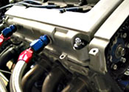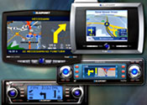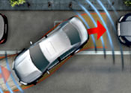
Powertrain & Safety | Comfort/Convenience & Vehicle Controls | Infotainment &  Communications | Driver Assistance
Engine Management  Electronic Suspension  Drive by Wire  Braking Systems  Power Steering  Airbags  Gearbox | Dashboard/Instrument Cluster  Lights/Seats  Climate Control  Voice Recognition  Remote Keyless Entry  Security Alarm Systems  Wiper/Window Control | Telematics  Navigation/GPS  Multimedia Systems  Audio Systems  Rear Seat Entertainment  Games Consoles  Tuners (SDR) | Night Vision  Lane Departure Warning  Adaptive Cruise Control  Collision Warning  Park/Reverse Assist  Tire Pressure Monitoring  Heads Up Display
Automotive electronic systems require increasing amounts of semiconductor contents which is projected to grow at a 9 percent annual growth rate. Couple this with shorter innovation or design cycles of 24 to 36 months means that pressure on system suppliers will be enormous while still meeting the technical, quality and cost requirements. Yet there is a growing trend toward the “platform concept” where with one basic design converges audio, video and data systems and somehow this according to the industry is to provide a means of model differentiation so we are now back to the Sebring and Stratus as mentioned above. Some choice, but yes this can make for a quicker turn around cycle.
Automatronics with its modular integrated approach shall outmatch the innovation design cycles and offer greater choice across the four segments listed above, but also forms a real choice away from the “platform concept” which offers cost effectiveness for other automakers but offers little as far as choice to the customer. “One ongoing policy at Automatronics is that at no point shall marketing out strip the manufacturing capabilities of the company such as what happened with Daewoo in 1997. Only by maintaining a success profile can we best achieve lasting quality, value and sustainability for our customers and ourselves (Automatronics)." Figure 3 below portrays the reasoning of this statements philosophy.

SWOT Analysis – Strength; weakness; opportunity; threat
Automartonics SWOT
“SWOT stands for Strengths, Weaknesses, Opportunities, and Threats. A company conducts the SWOT analysis as a part of the environmental appraisal process. The company identifies external and internal factors that could influence the sales of its products (Keller & Kotler, 2009).”
Strengths | Weaknesses
- Competitive advantages – ability to move rapidly to market responses  - Innovative aspects – modular designs do not require a full system “platform” response  - Resources, Assets and People – no waste with resources, assets pointed appropriately with employees at the height of competency  - Cultural, attitudes and behaviors – can march the attitudes and cultural wishes of consumers | - Lack of competitive strength – presently weak in name recognition and financial capital  - Processes and systems – it is unknown at present whether the concept will work in practical terms  - Gaps in capabilities – problem areas in teams and their deployment have yet to be ascertained  - Continuity and supply chain robustness – the supply chain has yet to be developed all unknown territory
Opportunities | Threats
- Technology development and innovation – highly adaptive modular systems shall prove as enhancement to present modes of thinking  - Global influences – with a much lighter, adaptive and on the go infrastructure products can reach areas difficult for others.  - Competitors' vulnerabilities – inflexible bureaucratic systems with high overhead  - Industry or lifestyle trends – products very adaptable over life times | - Economy – home and abroad – instability across the investment sector and overall underemployment may thwart buying  - Competitor capital and innovation – companies like Toyota have billions of dollars that can if it is realigned toward modular innovation do significant damage  - Market demand – this is truly unknown  - Supply chain incompatibility – product suppliers may have their production process so entrenched into the “platform” model that individual modular element production may be near to imposable as a switch over

Competitive Analysis – SWOT; market mix; product positioning
Toyota SWOT
Since its founding in 1937 the Toyota Motor Corporation has established a reputation for quality, safety and innovative craftsmanship Toyota hence is seen as a good corporate citizen of the world. “In March 2004, the Center for Auto Safety reported about sudden acceleration problems in 2002-03 Toyota Camry’s and Solaris and the 2002-03 Lexus ES 300 (Emison, 2009).” This formulated 5 years of back peddling by Toyota. “Before last August, Toyota had issued three limited recalls to replace floor mats and change an interior part that could catch on accelerator pedals. But after the fatal crash near San Diego, and the public release of the 911 tape, Toyota was forced to, as it said in the fall, “take a closer look” (Vlasic, 2010).” But this very public closer look has had the effect of sullying the stainless reputation of the Toyota Motor Corporation and its ability to effect change across its product line.

If anything Toyota’s real threat to Automatronics lies in Toyota’s ability to adapt to changing conditions. Toyota has found a proven winner with the Prius “…when it introduced the first hybrid electric-gasoline car, the Prius, Toyota was the leader. In 2002, when the second-generation Prius hit showrooms, dealers received 10,000 orders before the car was even available (Keller & Kotler, 2009, p. 323).” By any term this is called market moxie in future capabilities a position thus far Automatronics has not attained.

Toyota strengths | Toyota weaknesses
- International name recognition – has a long history and working relationship across the world  - Huge financial capital – has billions of overhead capital to throw in a new direction if it so chooses  - Established global supply chain – is well entrenched with producers and distributors  - Engineering innovation – years of innovation history  - Corporate citizen – community and philanthropic activities across the globe | - International name recognition – accidents and recalls creates dimming public view of company  - Callous and Stoic behavior – top executives and staff ignore the mechanical problems  - Entrenched bureaucracy – the right way, the wrong way and then the company way is the only way  - Failure to innovate – takes little action to solve the brake and acceleration issues  - Proven not so corporate citizen – blatantly caught lying about not having knowledge about problems
Toyota opportunities | Toyota Threats
- Change in public perception of name recognition – deep rooted resolution of issues through public relations campaigns  - Renew social commitment – as a global citizen company  - Detect and resolve problems when they are seen – new task force development  - Steer into a direction of open disclosure – third party oversight | - Financial titan – can outspend by billions with $203,687 million in sales  - Intermediate goods colossus – scores of $billions in assets  - Production goliath – produces over 7 million vehicles annually  - Supply chain emperor – has 320,808 supplier producers around the world  - Ability to adapt and change to new market demands – Proven ability to create and succeed in new hybrid auto market

Product Offering – current products; future products

Presently Automatronic products are under development in modular design systems. These products include every aspect of automotive parts and craftsmanship. Starting with the power plant there will be a variety of engines starting from 1.8, 2.4, 3.2, 4.8 liter models from small 4 to large 6 cylinder blocks. All automatic and standard transmissions shall be adaptable to each engine where switching over is a breeze. Steering columns shall be directly coupled meeting federal guidelines. Wheel base and suspension shall be held within a modular attachment. Dashboards, displays, electronics, seating and other interior parts can be mixed and matched. Upon ordering, parts are assembled where final colors and adaptations are applied to customer wishes. It will take two days to build and test your vehicle and two to three days to deliver to your location. So it will take one week from the time a customer orders a vehicle to its delivery. Here customers shall have their own personal conveyer custom built just for them.
Future products being considered are fully electric vehicles of the hydrogen fuel cell type and vehicle fittings with magnetic levitation modules or flying wing attachments. With flying wing attachments after you become flight certified for example you would drive to an Automatronics flight center at an airport rent a wing hook up to the interface docking coupler and simply fly to your destination and drop the wing and you drive off on business or visiting relatives and friends. Yes with an integrated flight control module your Automatronics trans-veyer just hooks up to a wing and flies. Flight plans shall be handled by an Automatronics flight controller under general aviation. You pay for fuel, overhead costs plus product markup, but it’s when you want to go and where you want to go anytime day or night. This is one of the advanced concepts for future products.

Comprehensive Communications Plan – TV/radio; print; events; trade shows; public relations; sampling
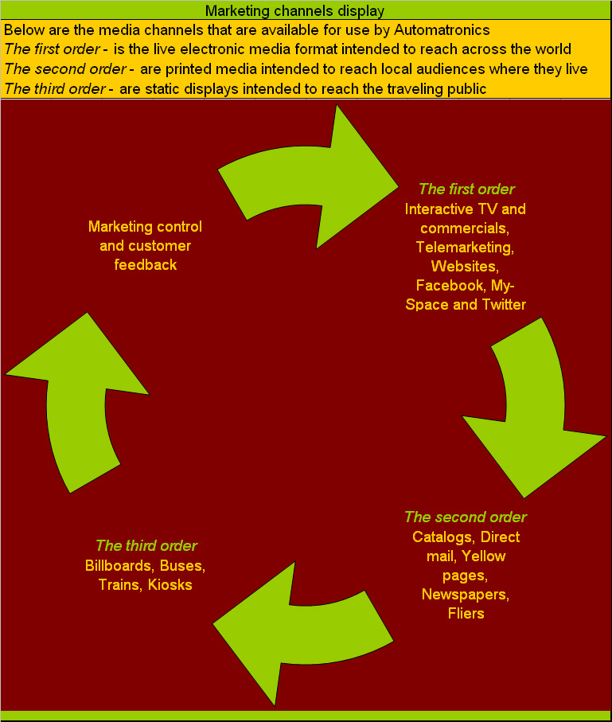
From the above marketing channels display earmarks Automatronics comprehensive communications plan. Starting with the first order of live electronic media interactive TV with promotional spots and feedback apparatuses shall be set up to assist with the greater understanding of people’s needs and thoughts about product renderings. Some telemarketing shall be set up to asses or survey a region or area in this way. The website’s integrated framing shall be a portal array fashioned after one of the leaders of this type wiserearth.org with an almost heuristic tactile feel as is seen with the advanced human operations across from the association of science and technology centers (ASTC) and the American association of museums (AAM) a very human systems approach. This shall help to facilitate a better usage and understanding of Automatronics by consumers. This shall links to Facebook, My-space and other forms of electronic media.
The second order such as catalogs shall offer descriptions of specifications and stylistics of product lines along with discount offerings across areas or regions aimed perhaps of relieving overproduction. The third order like billboards or static displays for the public shall be placed ironically around the competitors camps letting the public at large know that a clear alternative exists. And marketing control shall make the determinants of all the above matters as well as managing the team for use at conventions and automotive trade shows and TV presentations and commercials. Automatronics shall be marketed as a new total systems process for automotive sales, manufacture and distribution.
Automatronic’s basic line of market attack as noted by Keller & Kotler (2009, p. 303) shall be the “bypass attack - the most indirect assault strategy is bypassing the enemy altogether and attacking easier markets to broaden the firm’s resource base.” In the case of Automatronics the market is already a given which are all the myriads of people fed up with business as usual with the automotive industry in general.

Measurement or key success factors

The status quo is gone and as much as company’s like Toyota appear as free thinkers they are well entrenched in that status quo with a vast bureaucracy to maintain. This is what changes with Automatronics. The measurement of this Automatronics media campaign is to raise the awareness globally of this new and long awaited automotive process and product line initiating the placement of outlet shops and kiosks that will in two years be capable of meeting the demands for a new automotive way of life.
Success shall be measured as how well our resources align to the cost analysis percentages of Figure 4 aimed at functional sustainability as noted in Figure 3 with the start up profile success graph. The idea here is not to attain a maximum profit for profit sake upon the start up of the company. The idea is to attain a stable platform to run off allowing for sustainable growth of both Automatronics and its customer base.

Financials – sales; factory cost; break even analysis
Above in Figure 4 as taken from Toyota-global.com (2010) where an analysis percentage across 2008, 2009 and 2010 averages costs of products sold, costs of financing operations and selling, general and administrative expenses useful to derive cost figures for use by Automatronics.
For variable costs looking at Automatronic’s major competitor Toyota using figures attained off Toyota-global.com (2010) where 2009 revenues from sales were $203,687 million USD divided by 7,051 thousand units produced averages out to $28,887 per unit produced. Since Automatronics as the company describes it is to occupy Daewoo’s niche in the automobile market than according to the author Kim (2005) states that in 1994 Daewoo’s sales was 2,000,000 units. So this shall be considered “unit sales.” Now for our “fixed cost” or factory cost in Figure 4 above $2.402 billion is noted as the start up costs given marketing and product inception.
Below Keller & Kotler (2009, p. 392) portrays formulas for unit cost, markup price and breakeven point or volume:
Unit cost = variable cost + Fixed cost/Unit sales =
Unit cost = $28,887 + $2.402 billion / 2 million units =
Unit cost = $28,887 + 1,201 = $30,088 per unit
Markup price = Unit cost / (1-Desired return on sales) =
Automatronics desired return on sales say 10% or 0.1 on the dollar.
Markup price = $30,088 / (1 - 0.1) = $33,431
Break-even volume = Fixed cost / (Price – Variable cost) =
Break-even volume = $2.402 billion / ($33,431 - $28,887) =
Break-even volume = $2.402 billion / $4,544 = 528,609
So the break-even volume = 528,609 units sold. This is not that bad for a beginning automotive company like Automatronics if the company in fact does fill Daewoo’s 1994 void in the market of 2 million units sold per year. This shall mean that in a little past the first quarter of operations the break-even point shall be reached and with 1,471,391 units over that amount for the rest of the year. This makes for $49.19 billion in sales which includes the $4.9 billion in profit aimed at further operations all on top and beyond the break-even volume which equates to $17.67 billion. Now couple $17.67 billion with $49.19 billion equals $66.86 billion which makes for from Figure 4 Automatronics total assets of $54.59 billion, $12.27 billion over assets, not bad if you are considering this as the first years run.
The initial price of $33,431 might seem a little steep at first but than you have to think that you the customer are buying your vehicle for life where after the original vehicle is paid for costs go down dramatically and all you are doing then is switching out modular parts all built to last and all tailored to your personal taste. In fact after the original payment is done and that may be with a very affordable payment plan of ten years with full warrantees, Automatronics shall offer a vehicle lifetime maintenance program similar to the now automobile extended warrantee programs with one major difference. You a customer of Automatronics shall never have to worry about having transportation again and there is no waste in the process, your own very personal trans-veyer totally upgradeable and environmentally friendly.

References

Altera.com, Automotive Industry Trends, Retrieved July 10, 2011, from

http://www.altera.com/end- markets/auto/industry/aut-industry.html

Emison, B., (2009, November 6) Toyota Denied Sudden Acceleration Problem for More Than 5 Years, kansascity.injuryboard.com, Retrieved, July 20, 2011, from
http://kansascity.injuryboard.com/automobile-accidents/toyota-denied-customer-complaints-on-sudden-acceleration-problem-for-more-than-5-years.aspx?googleid=274028
Keller, K. L. & Kotler, P., (2009) Marketing management (13th ed) Pearson Prentice Hall, Retrieved June 30, 2011, from
http://digitalbookshelf.argosy.edu/#/books/0558503810/pages/15482633
Kim, B. (2005) Mastering business in Asia: Supply chain management. John Wiley & Sons (Asia) Pie Ltd 2 Clementi Loop. # 02-10, Singapore 129809
Toyota-global.com (2010) Annual report, purpose, perspective and passion, Retrieved, July 20, 2011, from
http://www.toyota-global.com/investors/ir_library
Toyota-global.com (2010) Toyota in the world, Retrieved, July 20, 2011, from http://www.toyota-global.com/investors/ir_library
United States Department of Labor, Bureau of Labor Statistics (2008) Employed, Retrieved, March 30, 2010, from http://www.bls.gov/news.release/archives/empsit_01092009.pdf
Vlasic, B., (2010, January 30) Toyota’s slow awakening to a deadly problem, nytimes.com, Retrieved, July 20, 2011, from
http://www.nytimes.com/2010/02/01/business/01toyota.html?pagewanted=all

