Marketing Communications

Automatronics

Module 6 Assignment 1

By
Randy K. Pruitt

For – B6026
Dr. Castaneda
Date – 06 August 2011

Introduction – Identify the company product or service selected and explain why you chose this specific item. Identify the target market for the product.
Introduction
Automatronics is a new concept in automobile manufacture and sales meeting the personal and environmental needs of our present era into the future. There comes a time when all must change and that time has come with the automotive industry. Starting with fully modular component systems from different chassis to interior design and colors Automatronics will meet the needs of the most particular customer from the young and outrageous to the most sophisticated conservative of any ages. With sales generated either online, from an outlet store which can offer a test drive with a basic unit or kiosk with parking lot a customer can order their very personalized vehicle and by the end of the week stop by the store or kiosk and drive off with their personal conveyer warrantee in hand. Similar to ordering from Dell computer the ordering shall be done item specific such as engines, transmissions, chassis, interior, electronics down to the very knobs themselves. If you want pop art paisley or a traditional mahogany look, it’s yours. Our appeal is to the young and old alike from techno to traditional with the flare of the international and the grounding of the cultural Automatronics vehicles shall meet the eye of the beholder. To facilitate the production process shall be a network of regional production distribution centers hooked to supply chain regional hubs to stream line efficiency in process. Similar to a Wal-Mart distribution center components shall enter receiving docks for semi-final processing such as the addition of color or fitted with interface adapters for final construction which takes two days which is then shipped directly to the customers hands. All vehicles are produced by the order eliminating the traditional dealership with parking lots of cars both new and old just sitting around as future waste. Every vehicle shall be produced to fill a particular order, one order one vehicle and all Automatronics parts shall be fully recyclable for use as reproduced used vehicles or added to the environmental waste stream. Automatronics shall be marketed as a new total systems process for automotive sales, manufacture and distribution with a build up starting at first with the market size of the Hyundai at $54.59 billion in 1997 per Kim (2005) when Daewoo went out of business.
Discuss the goals and objectives of the plan – Category need, brand awareness, brand attitude, and brand purchase intent
Automatronics by category meets the needs of a modern lean on the go culture based on perspicuous taste and environmental consciousness. Here customers can have their cake and eat it to with personalized style and color. As the use and awareness of Automatronics products shall reach the appropriate market recognition goals society when it comes to the automotive industry shall see that the days of business as usual is over as streamlined methods are applied to all processes of this automotive business. This is dependent on Automatronics meeting the relevant and utilitarian needs of customers while meeting the U.S. Highway Administration and the Department of Transportation safety requirements. So here with Automatronics customers shall see a true alternative to the status quo purchasing off the dealership car lots where the models look the same with very little personal adaptation abilities including the switching over to an alternate power vehicle when the time comes.
The period of this marketing campaign is two years while production, distribution centers and assembly capabilities are built.
Design communications and select channels – Message? and creative strategy, and the channels of distribution you recommend pursuing—mass channel, direct to consumer, etc.
Message

Automatronics is the evolution in personal transportation systems that shall maintain the highest innovative personalized automotive production customer based system in the world. Staying at the very forefront of management and supply chain philosophy Automatronics shall maintain the technological edge and quality control analysis in streamlining processes equating to the very best in lasting durability, adaptability and cost in personal conveyance vehicles.

Creative strategy

“The process is the product the product is crafted by the customer, one purchase one vehicle for life (Automatronics).” The true creative strategy behind Automatronics products is with its modular approach and design integration. This means that whatever vehicle you purchase from us, from its base universal-body shell, engines and drive trains, external side panels, doors, windshields, dashboard and components, interior seats and cabin elements through a system of interlocking conversion elements all like functioning parts shall be interchangeable with a minimum of effort while providing a maximum in durability and safety. So you purchase your vehicle once and then if you want to go from a two door to a four door, lighter engine to a more powerful one, from a sedan to a pickup truck this can be done with a minimum of disruption at a designated local service area by simply ordering the new modular elements or go with refurbished used parts at a lower cost where all parts are recycled minimizing waste.

Marketing channels

Below is a marketing channels display that is useful for Automatronics starting from the first, second and third descending orders of priorities as outreach tools for whole system promotions of the product line generally or individually targeted audiences such as university students or sophisticated retiree communities.
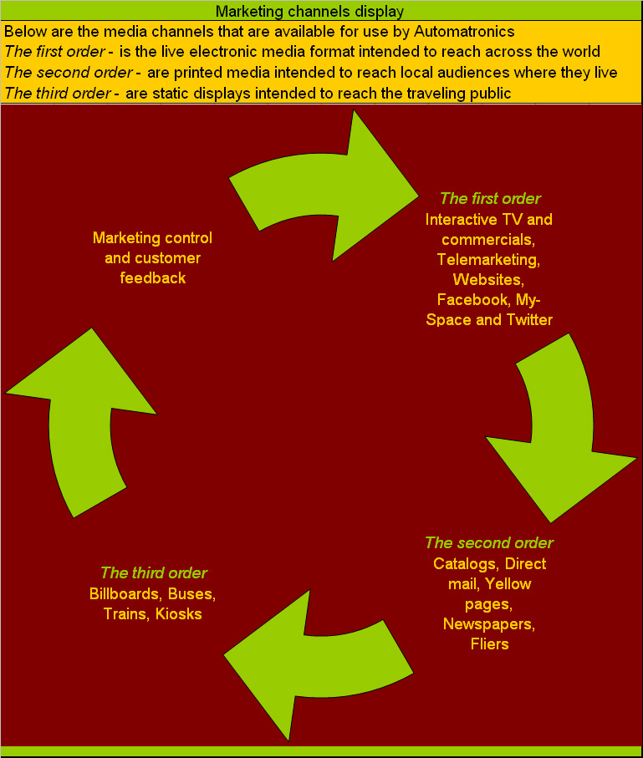

Budget – establish a budget and parameters for spending
Budget
Below Figure 1 as taken from Toyota-global.com (2010) Annual report where an analysis percentage across 2008, 2009 and 2010 averages costs of products sold, costs of financing operations and selling, general and administrative expenses useful to derive cost figures for use by Automatronics.
“One ongoing policy at Automatronics is that at no point shall marketing out strip the manufacturing capabilities of the company such as what happened with Daewoo in 1997. Only by maintaining a success profile can we best achieve lasting quality, value and sustainability for our customers and ourselves (Automatronics)." Figure 2 below integrated between Kim (2005) and Toyota-global.com (2010) Annual report illustrates the success profile of administrative marketing verses manufacturing productions units of like sizes. Figure 2 demonstrates the hazards to any company of a top heavy administrative marketing system.

Media mix – Recommend the media mix based on the eight major modes of communication discussed in the text.
As recommended Keller & Kotler (2009) below are the eight modes of communications as they are applied to the Automatronics marketing campaign:
- Advertising – Automatronics shall pay for advertising time on major TV networks and internet websites during high traffic or usage times
- Sales Promotion – One avenue is the use of Radio Program lotteries where as an example the 10th caller on a certain radio show wins a car. This type of media process has the effect of drawing people’s interest to that program and product.
- Events and experiences – Here at the automotive conferences and expos Automatronics can present the clear difference in both business modeling and technological approaches compared to other manufactures.
- Public Relations – Public relations as an aspect of the company shall concern itself with the integration of customer wishes and product feedback more than playing the usual face saving role of a firm.
- Direct marketing – Automatronics shall limit the amount of person to person direct marketing to customers due to expediency and cost. However all other electronic media methods such as e-mails, Facebook and even YouTube as these methods are relatively inexpensive and can be handled by only a few individuals. The company will do direct market canvassing to build a data base for use of product distribution and allocation as an attempt to limit or increase the amount of product overhead to individual areas or regions.
- Interactive marketing – Automatronics.com shall offer customers one of the most user friendly platforms out on the Internet. Here we shall show our out of the box strength in thought with our approach to the human touch. Patterned after the high tech portal array of the natural capital institute (NCI) wiserearth.org and applying the human touch of the association of science and technology centers (ASTC) astc.org and the American association of museums (AAM) aam.org websites Automatronics shall distinguish itself as an innovator in website navigation where consumers can browse mix, match and literally build their vehicle with a sense of artistry like painter with a brush on canvas.
- Word of mouth marketing – Here at Automatronics we see word of mouth as a sales and production aftermarket effect where the vehicles may take on an appeal in some urban area or some cultural group. This is where we see word of mouth most effective.
- Personal selling – Certainly where and when customer face to face interactions do occur personal selling shall come into play. On the larger scale Automatronics feels that personal selling as an initiative due to resources in manpower that it is best to focus that attention on intermediate goods suppliers and outsourcing supply chain producers.
Automatronics sees the above descriptions in modes of communications the most efficient use of manpower and capital resources throughout this the startup of Automatronics as a company throughout the two year media campaign.
Measure – What do you expect the results of the media campaign to be for your company? How will you measure success?
The expectations of this Automatronics media campaign is to raise the awareness globally of this new and long awaited automotive process and product line initiating the placement of outlet shops and kiosks that will in two years be capable of meeting the demands for a new automotive way of life. The status quo is gone and as much as company’s like Toyota appear as free thinkers they are well entrenched in that status quo with a vast bureaucracy to maintain. This is what changes with Automatronics. Success shall be measured as how well our resources align to the cost analysis percentages of Figure 1 aimed at functional sustainability as noted in Figure 2 with the streamline success graph. If Automatronics lies between the startup graph and the streamlined graph we will know that we have a sound footing for future operations. But if on the other hand we are looking more like Daewoo where an exhaustive marketing effort is put forth and our machinery to comply is inadequate to meet the task then we are indeed in trouble as a company. The idea here is not to attain a maximum profit for profit sake upon the start up of the company no. The idea is to attain a stable platform to run off allowing for sustainable growth of both Automatronics and its customer base.
References
Keller, K. L. & Kotler, P., (2009) Marketing management (13th ed) Pearson Prentice Hall, Retrieved June 30, 2011, from
http://digitalbookshelf.argosy.edu/#/books/0558503810/pages/15482633
Kim, B. (2005) Mastering business in Asia: Supply chain management. John Wiley & Sons (Asia) Pie Ltd 2 Clementi Loop. # 02-10, Singapore 129809
Toyota-global.com (2010) Annual report, purpose, perspective and passion, Retrieved, July 20, 2011, from
http://www.toyota-global.com/investors/ir_library

